Nama : Ardiansah Nur Rohman
NIM : 230322607922
Malang DEM_SRTM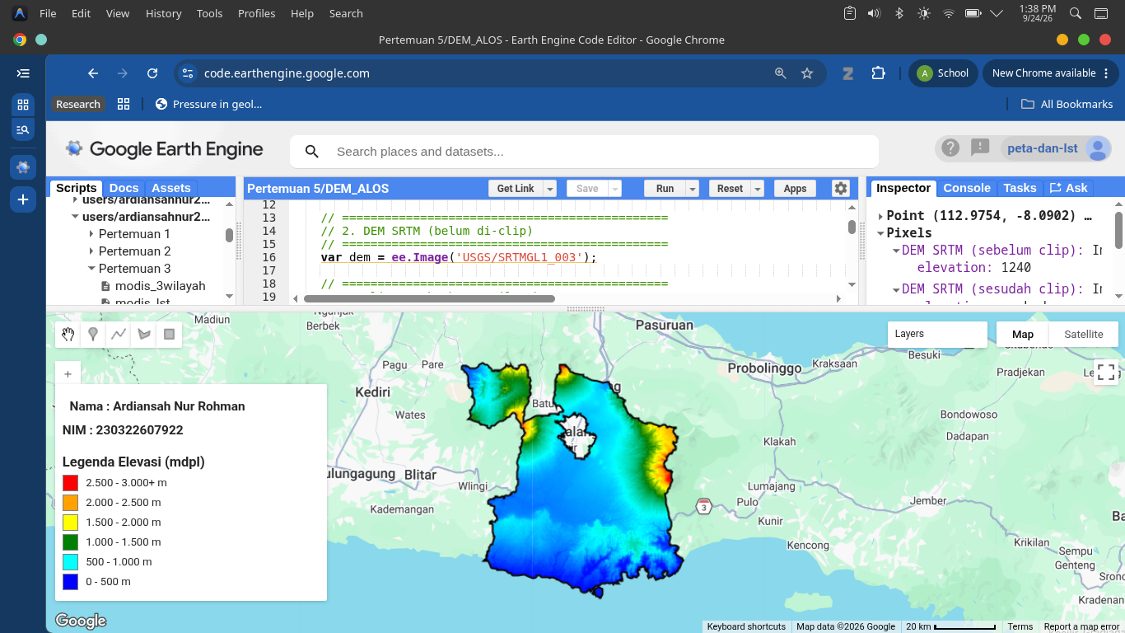
Malang DEM_ALOS
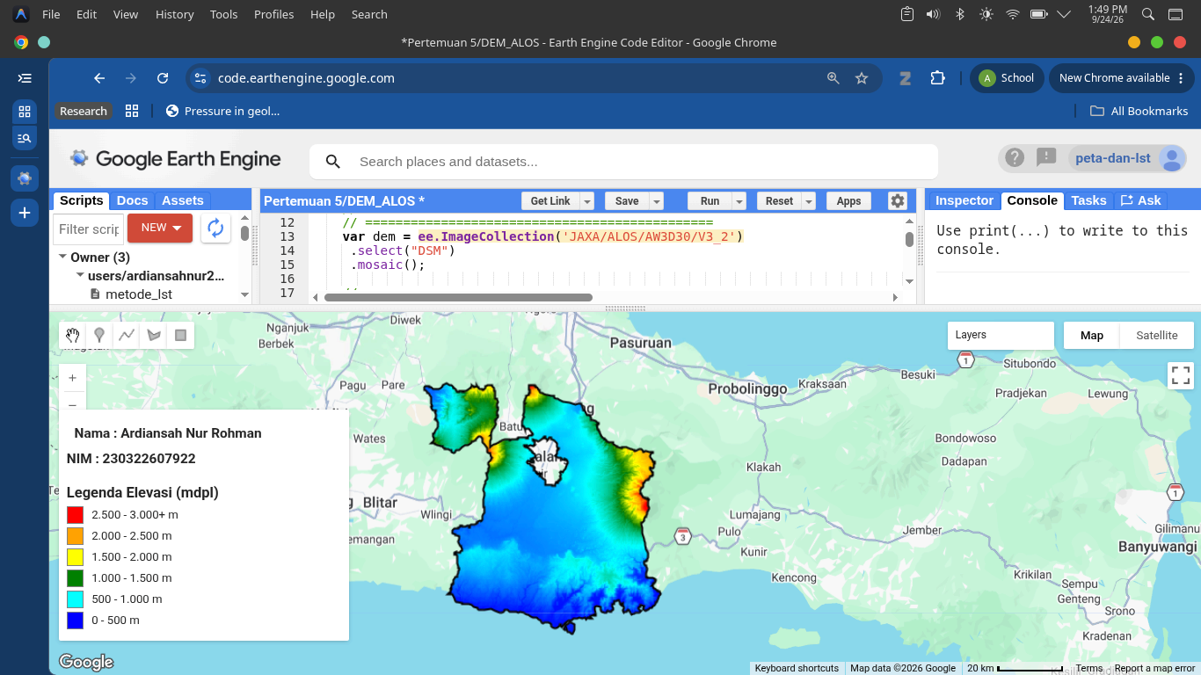
Malang DEM_ALOS – DEM_SRTM (Selisih)
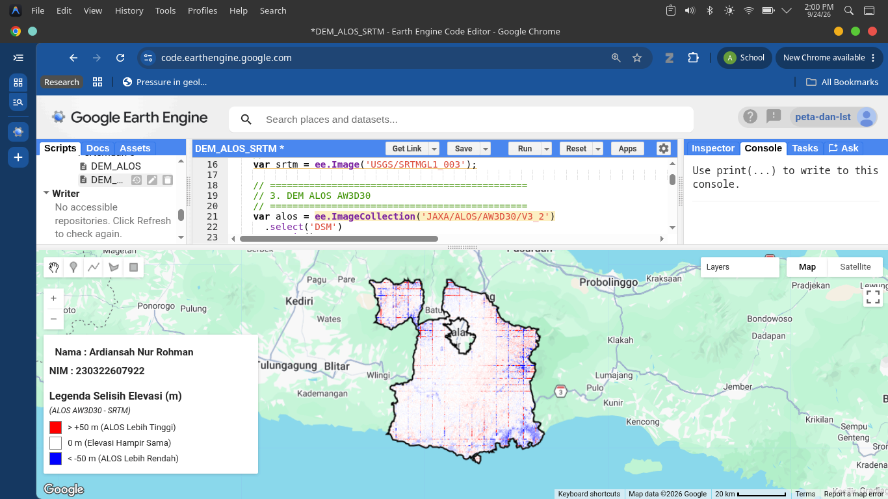
JATIM DEM_SRTM
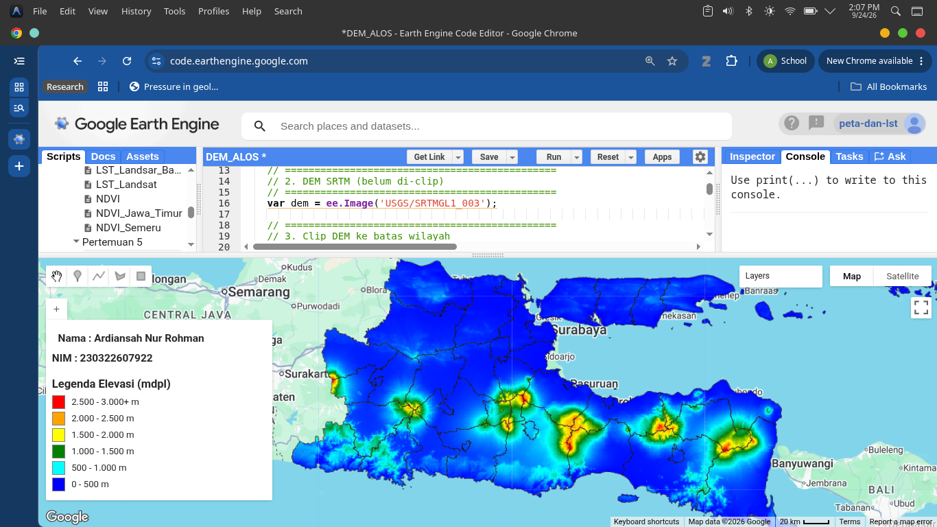

JATIM DEM_ALOS
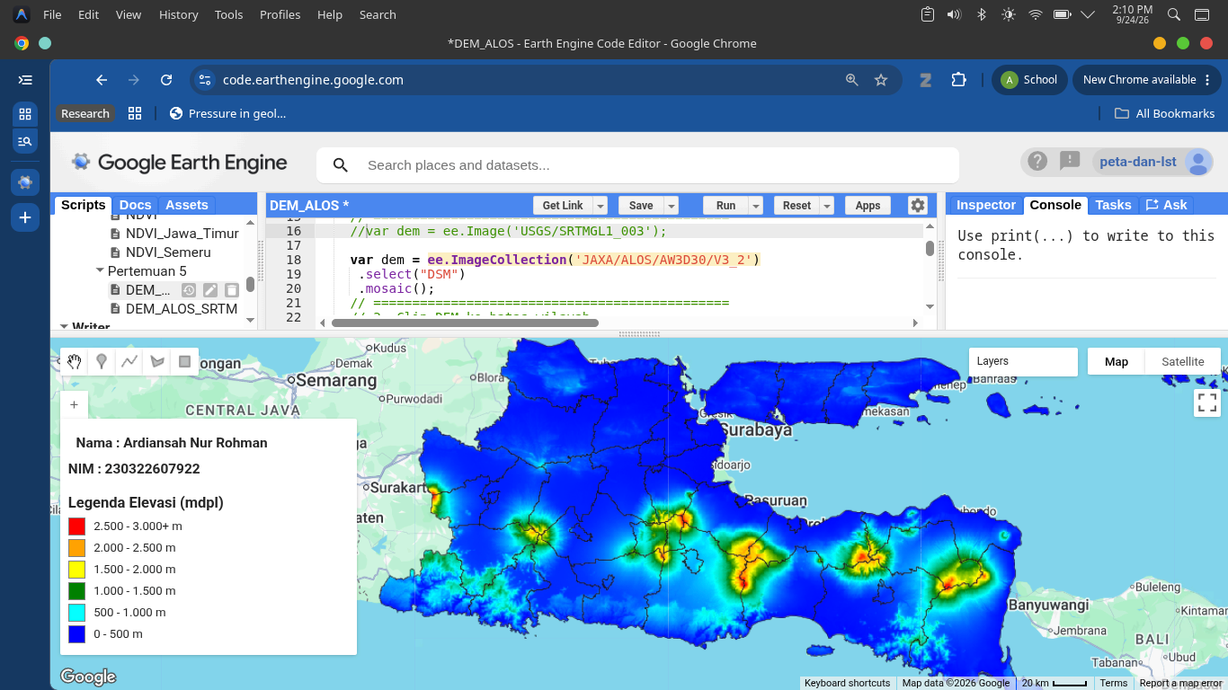
JATIM (DEM_ALOS – DEM-SRTM) (Selisih)
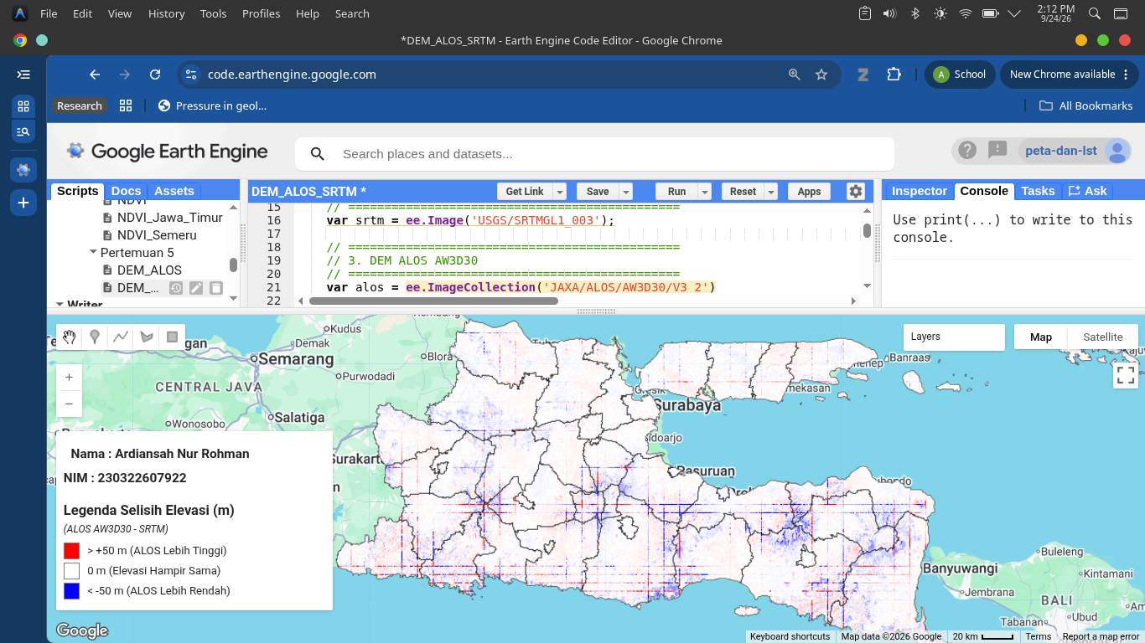

Compare DEM VS LST 8 VS LST 9 10 Titik
No | Longitude | Latitude | Elevasi SRTM (m) | LST L8 | LST L9
1 | 111.838249° | -6.878334° | 58.00 m | 45.55 °C | 48.17 °C
2 | 112.750114° | -7.259932° | 3.00 m | 41.43 °C | 42.02 °C
3 | 112.327140° | -7.744637° | 380.00 m | 33.97 °C | 31.13 °C
4 | 112.420524° | -8.081970° | 431.00 m | 32.39 °C | 32.51 °C
5 | 113.672966° | -8.467923° | 383.00 m | 27.09 °C | 27.68 °C
6 | 111.250480° | -8.196164° | 371.00 m | 25.26 °C | 27.95 °C
7 | 112.761100° | -7.886133° | 905.00 m | 27.05 °C | 27.31 °C
8 | 112.512127° | -8.001762° | 1023.00 m | 27.39 °C | 25.88 °C
9 | 112.464470° | -7.739194° | 1634.00 m | 21.64 °C | 20.97 °C
10 | 112.903923° | -8.011262° | 2209.00 m | 19.29 °C | 20.14 °C

DEM Vs LST Landsat 8
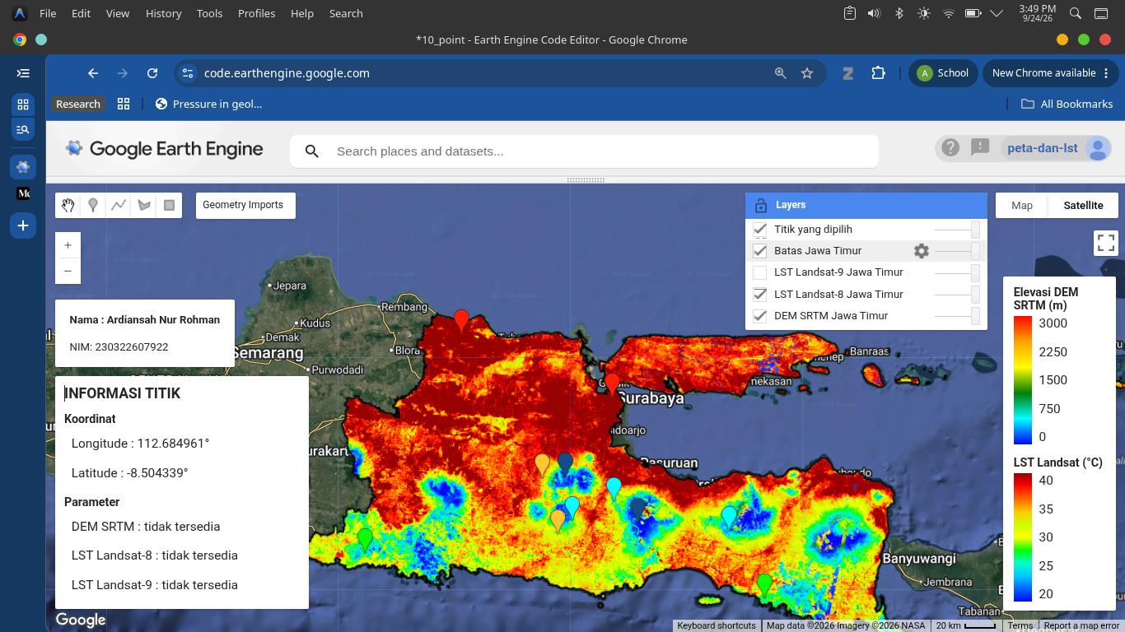

DEM Vs LST Landsat 9
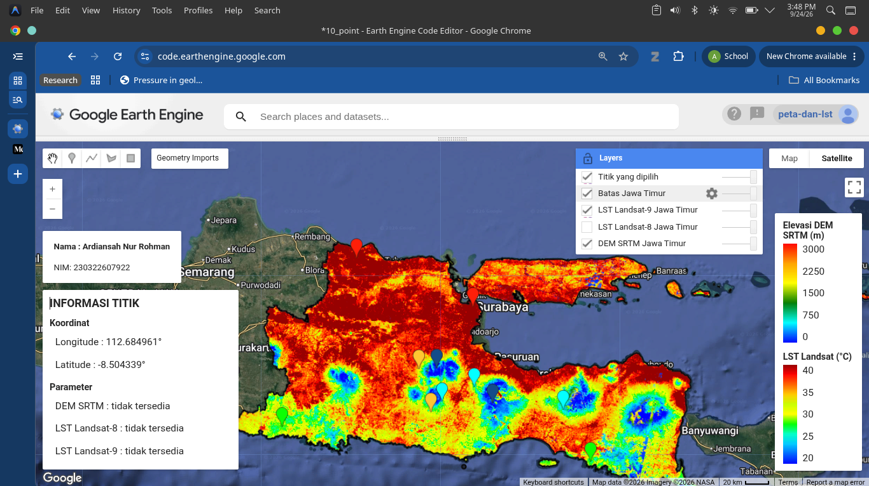

Grafik DEM Vs LST Landsat 8 & LST Landsat 9
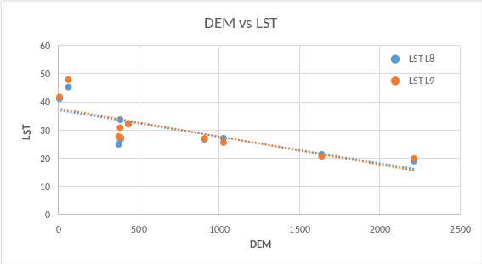
(Menurut fitting grafik DEM Vs LST L8 & LST L9 maka semakin ketinggannya naik (DEM naik) maka nilai temperatur akan menurutn (Nilai LST akan turun) Baik LST Landsat 8 maupun LST Landsat 9)
DEM & LST Departemen Universitas Negeri Malang
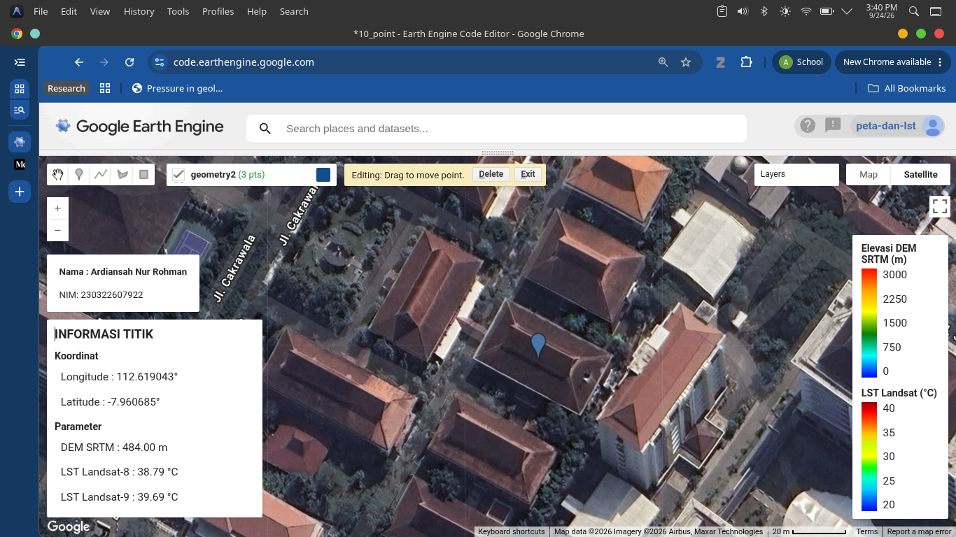
No | Longitude | Latitude | Elevasi SRTM (m) | LST L8 | LST L9
F | 112.619043° | -7.960685° | 484.00 m | 38.79 °C | 39.69 °C

